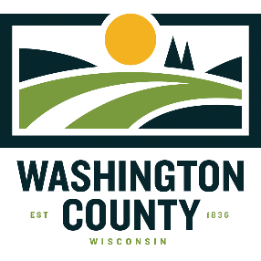
Stephanie Plaster, Agriculture Educator

Washington County Extension Office
Public Agency Center
333 East Washington Street, Suite 1200
P.O. Box 2003
West Bend, WI 53095-2003

stephanie.plaster@wisc.edu

West Bend (262) 335-4477
Wisconsin 800-616-0446 ext 4477
Fax (262) 335-4863 “or 711 for Relay”
Web Page: http://washington.wisc.edu

April 6, 2019

Dear Swine Exhibitors, Parents &/or Guardians:

Enclosed in this packet is one copy of the one Market Hog Project Record, two copies of the Market Hog Feeding Plan, a statement referencing Swine Health Requirements for the 2019 Fair, and an explanation of the Youth for the Quality Care of Animals certification program.

You should indicate on the registration form if your animal is Home Bred and Raised. However, you will not need to decide which animals will be entered in the Home Bred Raised market class until final weigh-in at fair.

MEAT ANIMAL SALE EDUCATIONAL PROGRAM REQUIREMENTS:
Exhibitors must complete two educational requirements approved by the Sale Committee in order to sell their animals. These programs are listed in the Educational Calendar. Carefully read the enclosed Livestock Project Educational Policies (reverse side of Certificate of Participation) for more information.

Evidence of completing the educational programs, Certificates of Participation must be returned to the Extension Office by June 30 or exhibitors will not be allowed to sell. On the enclosed Certificate of Participation, youth attending an educational program must obtain the signature of someone organizing or conducting the educational program. You are encouraged to deliver Certificates of Participation well ahead of the deadline. It is your responsibility to complete the form and obtain the appropriate signature(s). If you have any questions, need more forms, or lose a form, please contact the Extension Office.

The minimum market hog weight is 225 lbs. in order to be eligible for the livestock sale. There is not a maximum weight. Each exhibitor must return the Washington County Market Hog Project Record to the Sale Committee at the Washington County Fair in order for his or her animal to be in the sale.

Exhibitors may complete a copy of the Market Hog Feeding Plan for one of their education requirements if returned to the Washington County UW-Extension Office by May 6, 2019. The feeding plan should be a projected estimate of the amount of the feed and the cost of feed for feeding one animal. We hope that you will follow your feeding plan as a guide to getting your animal in the best condition for the fair. We have provided you with two copies of the feeding plan worksheet so you may keep one for your own use and records.

Overnight Pass Application: If you have an important, specific, and valid need to stay overnight on the fairgrounds, an overnight pass will be required. Applications will be available at the UW-Extension Office and at the Washington County Fair Park Office. Complete and return to the UW-Extension Office by June 30. They will be considered only on an emergency basis after this date. Junior exhibitors must be 12 years old. All junior exhibitors must have either a parent, guardian, or chaperone in order to stay, and they must also apply for an overnight pass.

We hope that your livestock project will be a successful and educational experience. If you have any further questions, please feel free to contact me.

Sincerely,

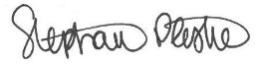

Stephanie Plaster, Agricultural Educator
UW-Extension

