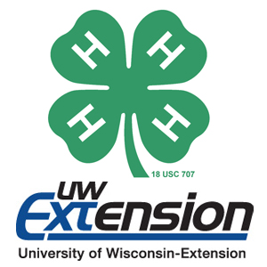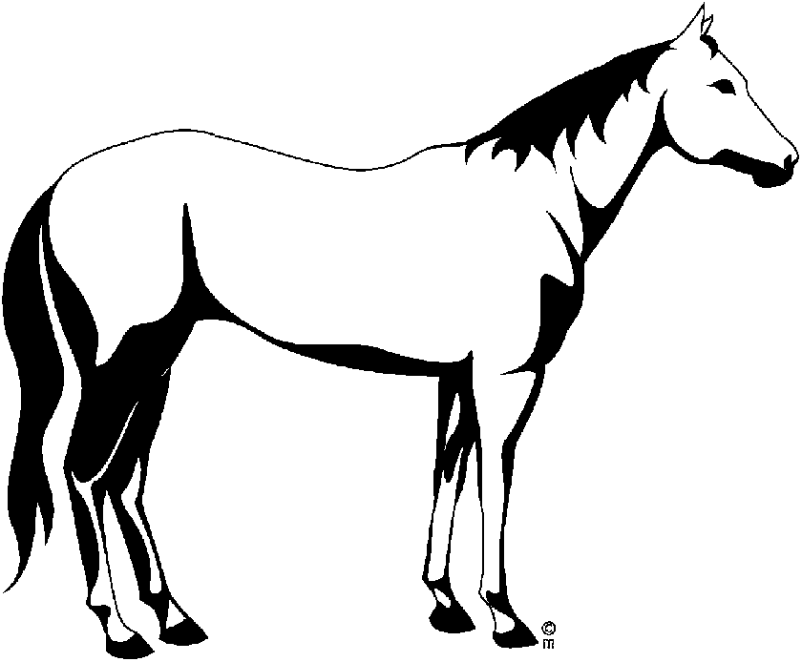 WASHINGTON COUNTY
4-H HORSELESS HORSE PROJECT SHEET
Year: ______to ______

Name Grade Years in Project
Are you a Youth Leader in this project? Yes No

Explain why you are taking this Project and what you hope to learn/accomplish this year (your goal):

To complete this Project, you must complete nine of the following activities:

Activity | Date Completed
Give one talk or demonstration
Name the parts of the horse
Name the parts of the saddle
See a horse movie
Read a horse book
Read a horse magazine
Attend a horse show
Ride a horse
Attend a horse sale
Groom a horse
Tack a horse
Visit a horse farm
Visit with a farrier
Visit with a veterinarian
Visit a hunt, race, and/or trail ride
Tour a riding school
Visit a tack shop
Visit with a horseman (horse owner)
Visit a feed store
Others (list)

PROJECT MEETINGS
Did you have a Club Project Leader? Yes No
Number of Club Project meetings held: _____ Number I attended ____
Did you have a County Project Leader? Yes No
Number of County Project meetings held: ____ Number I attended ____
Was the project self-guided? (Member worked independently without a project leader) Yes No

PROJECT TALKS AND DEMONSTRATIONS YOU HAVE GIVEN
Date |  | Title |  | Where
OTHER ACTIVITIES AND EVENTS DONE IN THIS PROJECT
Date |  | Type of Event |  | When/Where

PROJECT EXHIBITS

*Must have exhibited at county fair to be eligible for County Award

Item |  | Where |  | Placing/Award

4-H Horseless Horse Experiences: You must include the following:
- Did you meet your goal? WHY OR WHY NOT?

- How will you use what you learned this year?

- What was your favorite part of this project?

- What projects or challenges did you have? How did you solve them?

- Explain your leadership and/or teaching responsibilities in this project. If none, write “not applicable.”

*Add pictures and/or news articles specifically related to this project following this form to illustrate what you did in the project this year.

