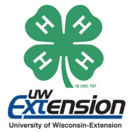
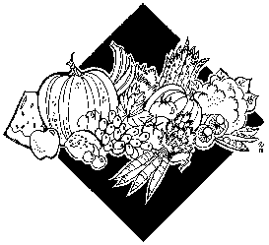

WASHINGTON COUNTY
4-H FOODS PROJECT SHEET

Number of Years in Project Are you a Youth Leader in this project? Yes No
Check your Project: Six Easy Pieces Tasty Tidbits You’re the Chef Foodworks Self-determined
Pre-Project Planning: What new ideas/skills/experiences do you want to learn/try/discover? These are your project goals.

During the Year: What did you do in this project throughout the year?

Date | Location | Activity  (Food Item Prepared, Demonstration, Project Talk, Workshop) | Skill(s) Learned | Cost of item(s) purchased | Other information you would like to track (hours, expenses, tools used)

PROJECT MEETINGS

Did you have a Club Project Leader? Yes No Number of Club Project meetings held/attended: _______/_______
Did you have a County Project Leader? Yes No Number of County Project meetings held/attended: ______/______
Was the project self-guided? (Member worked independently without a project leader) Yes No

PROJECT EXHIBITS
*Must have exhibited at county fair to be eligible for County Award
Item |  | Where |  | Placing/Award

Post-Project Reflection: You must answer the following questions.

- Did you meet your goal? WHY OR WHY NOT?

- What was your favorite part of this project?

- Describe how you will apply/use one of the project skills listed above, in the future.

- What problems or challenges did you have? How did you solve them?

- Explain your leadership and/or teaching responsibilities in this project, if any. If none, write “n/a”

